DAY 4 REPORT – BASELINE MODEL (CNN)

Title: Brain Tumor Detection using Deep Learning

1. Objective
The objective of Day 4 is to build and train a baseline Convolutional Neural Network (CNN) model using the prepared data pipeline and evaluate its performance to establish an initial benchmark.

2. Model Overview
In this stage, a simple CNN model is implemented for binary classification (Tumor vs Healthy). This baseline model helps in understanding initial performance before applying advanced techniques like transfer learning.

3. Model Architecture
The CNN model consists of the following layers:
- Conv2D (32 filters) + ReLU activation
- MaxPooling2D
- Conv2D (64 filters) + ReLU activation
- MaxPooling2D
- Flatten layer
- Dense layer (128 neurons)
- Output layer (Sigmoid activation)
👉 This architecture follows:
Conv → Pool → Dense
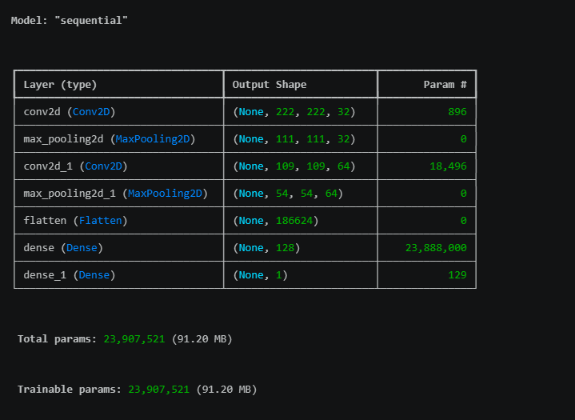
Figure: CNN Model Architecture (Baseline Model)

4. Model Compilation
The model was compiled using:
- Optimizer: Adam
- Loss Function: Binary Crossentropy
- Metric: Accuracy
This configuration is suitable for binary classification problems.

5. Model Training
The model was trained using:
- Training Generator (augmented data)
- Validation Generator
- Number of Epochs: 10
The model learns features such as edges, textures, and tumor patterns from MRI images.

6. Performance Visualization
Training and validation performance were visualized using accuracy and loss graphs.
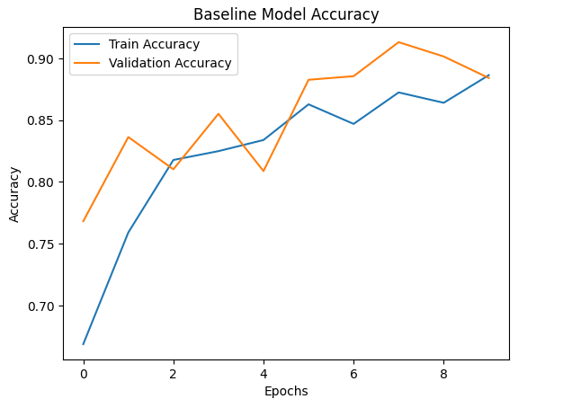
Figure: Training vs Validation Accuracy
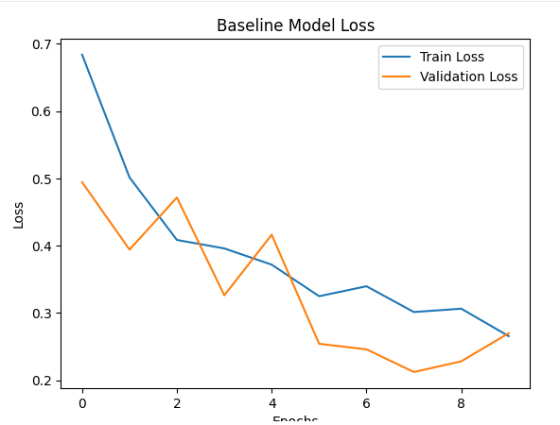
Figure: Training vs Validation Loss

7. Model Evaluation
The model was evaluated on the test dataset to measure real-world performance.
Figure: Baseline CNN Test Accuracy

Result:
- Baseline Accuracy: 89%

8. Key Insights
- The CNN model successfully learned basic image features
- Accuracy is decent but not sufficient for medical-level prediction
- Validation performance shows slight fluctuations
- Model may suffer from overfitting

9. Challenges Identified
- Limited feature extraction capability
- Overfitting risk
- Requires deeper architecture for better performance

10. Conclusion
The baseline CNN model provides an initial performance benchmark. While it performs reasonably well, it lacks the ability to capture complex patterns in medical images. This highlights the need for more advanced techniques.

11. Next Step
In Day 5, transfer learning techniques using pretrained models such as MobileNet, ResNet, and VGG will be applied to improve accuracy and model performance.

STORYBOARD
- Input: Preprocessed MRI Images
- Data Pipeline: Train / Validation / Test split
- Model: Baseline CNN
- Training: Feature learning
- Output: Tumor / No Tumor prediction
- Improvement: Transfer Learning

DAILY TASK REPORT

What I did today:
- Built baseline CNN model
- Defined architecture (Conv → Pool → Dense)
- Compiled model
- Trained model using generators
- Evaluated model on test data
- Plotted accuracy and loss graphs

What I will do next:
- Apply transfer learning models
- Improve accuracy using pretrained architectures
- Compare multiple models

Issues:
- Slight overfitting observed
- Limited accuracy
- Need for deeper models

